|  |
| --- |
| Creating AXI-LITE ‘Custom IP’ in Vivado |
| Lab for COMP4601 |
| Developed by: Shivam Garg |

Contents

1 Introduction 2

2 High-level design configuration 3

3 Creating Custom IP 4

3.a Generating a Custom IP component 4

3.b Creating a Project file for the Custom IP 7

4 Customising the Custom IP 10

4.a AXI Tutorial 10

4.a.i AXI Writes 11

4.a.ii AXI Reads 12

4.b Customising the Custom IP 13

4.b.i Changes to Slave_AXI 14

4.b.ii Changes to Toplevel 15

5 Packaging and testing your IP 17

5.a IP Packager (Within the Custom IP’s Vivado project) 17

5.b IP upgrade in high-level design (Within the high-level Vivado project) 20

5.c Interfacing with the Custom IP 21

6 Implementation Exercises 23

6.a Timer implementation 23

6.b FIFO implementation 24

6.c GPIO implementation 26

6.d Block RAM implementation 27

7 Conclusion 29

# Introduction

The aim of this lab is to introduce a design flow that will allow you to create your own custom Intellectual Property (Custom IP) targeted at a Zynq device using Xilinx’s Vivado 2013.4. The lab has been created for senior undergraduates using the ZedBoard. We assume the reader is familiar with the use of VHDL for specifying hardware. The lab explains how to modify the generated component, by focusing on how the AXI-LITE protocol works and how it can be utilised to establish a two-way data flow between the Processing System (PS) and the hardware component implemented in programmable logic (PL). This lab concludes on methods for maintaining and integrating this IP as part of a larger design.

As a high-level overview, this document will cover the following:

1. Setting up your Vivado high-level design, focussing on the configuration of the Processing System.
2. Using Vivado built-in tools to generate your own ‘Custom IP’ and modifying this IP.
3. Provides a tutorial on the AXI protocol that explains the critical modifications that allow the Slave AXI implementation to be abstracted, thereby making the AXI communication logic as simple as possible.
4. Shows you how to package and upgrade your IP. Sample software will be presented in order to test the modifications that were made to your hardware.
5. The penultimate section of this documentation consists of a series of implementation exercises. These exercises are designed to get you comfortable with developing custom IP, and to familiarise you with alternative ways of interfacing via the AXI bus.
6. Concludes this lab by listing methods of going forward and developing your own hardware based solutions.

By the end of this lab you should be able to generate your own IP quickly, implement hardware solutions, and effectively utilise the AXI bus to transfer data between the PS and the PL. You’ll also become proficient in the hardware design flow within the Vivado framework, and learn methods of debugging for producing hardware solutions as effortlessly as possible.

# High-level design configuration

The first step in this lab is to use Vivado to configure a high-level design that features a ZynQ7 processing core. For detailed instructions on the Vivado design flow please refer to Lab1 of the Xilinx Advanced Embedded Design course. As we progress through this lab, we will create custom AXI based IP components that provide fundamental hardware implementations such as a timer, a FIFO and GPIO.

The starting point for this lab is the following high-level configuration:

* Instantiate a Zynq7 processing system with UART1 enabled.
* Apply block automation (without board pre-sets applied) to connect DDR and FIXED_IO to external pins
* Check that your bock diagram matches the diagram shown in *Figure* 2*‑*1.

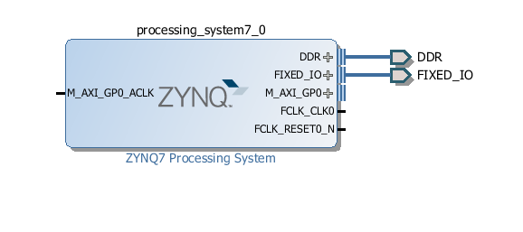

Figure 2‑1: Initial design

# Creating Custom IP

In this section you will be creating our own Custom IP which features an AXI-LITE interface for communication between the Processing System (PS) and the Programmable Logic (PL). We will then connect this IP to the PS and prepare a project file so that you can readily modify the design later.

## Generating a Custom IP component

1. Open the project created in Section 2. Click on **Project Settings**, then ensure that the Target Language is set to **VHDL** (else the generated IP will be in Verilog). Click OK when done.

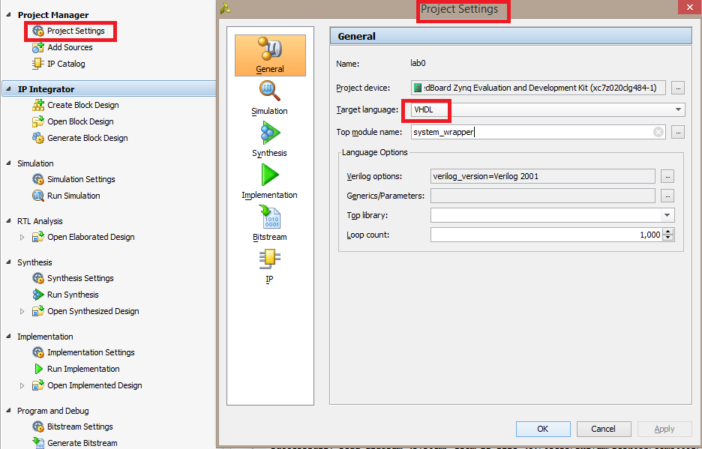

Figure 3‑1: Step 3.1, Project target language

1. Go to the **tools menu** > “Create and Package IP”
2. On the introductory screen, select the **next** option.
3. Select “**Create new AXI4 peripheral**” and then in the IP location, go up one level in the directory hierarchy from where the high-level project file is located. The high-level project directory and the IP that will be created should be located in the same directory (e.g. C:/…./XX/high-level & C:/…/XX/IP)

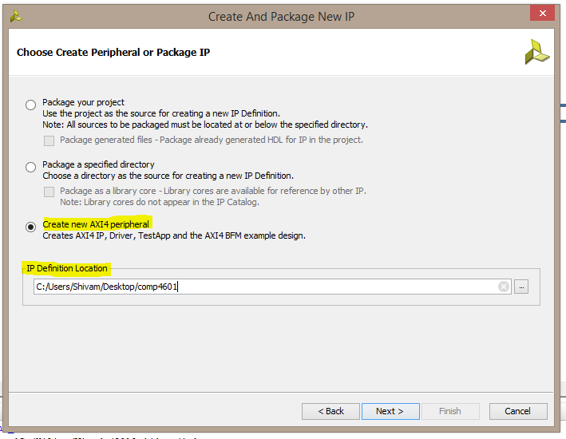

Figure 3‑2: Step 3.4, selecting IP type and location

1. Name the IP as “**lab0_ip**”, update the display name, and provide a description of the peripheral.

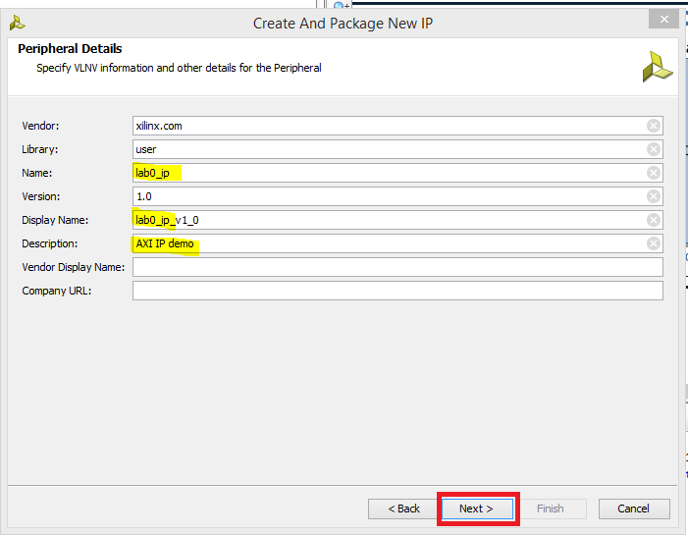

Figure 3‑3: Step 3.5, naming the new IP

1. In the next menu, keep the **default** options selected as shown in *Figure* 3*‑*4.
   * **Interface Type (LITE)** – Full and Steam AXI allows for burst transfers (4 packets at a time) and continuous data transfers respectively. When coupled with other peripherals, such as DMA controllers, these AXI protocols can be essential for meeting throughput requirements. AXI LITE, on the other hand, is a simpler protocol that satisfies the minimum hardware requirements of the AXI bus. This means that there will be fewer signals and state to worry about when designing your custom IP.
   * **Interface Mode (SLAVE)** – Since this IP is going to be issued commands by the processor this IP will act as a Slave.
   * **Data Width (32)** – For simplicity, we will keep the bus at the default width.
   * **Number of registers** **(4)** – This option will affect the generated Slave AXI code. With four registers, the data transferred from Master to Slave will be stored in 4 unique registers. The 4 least significant address bits are used to multiplex between these registers (b0000 first register, b0100 second register, b1000 third register and b1100 fourth register. The last two bits are always “b00” due to 32 bit width alignment).

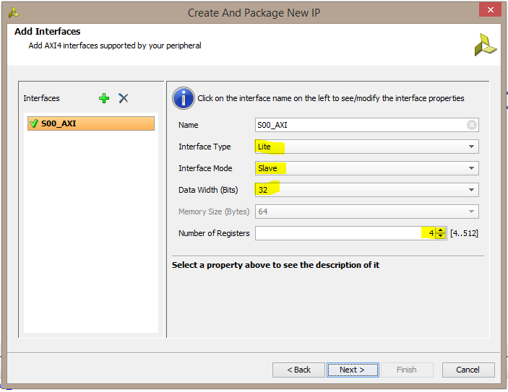

Figure 3‑4: Step 3.6, configuring AXI protocol for IP

1. When you are happy with the configuration, click **Next**.
2. On the “**Generation Options**” screen, leave the options unchecked and click next.
3. Finally, select “**Add IP to catalog**” and hit **finish.**

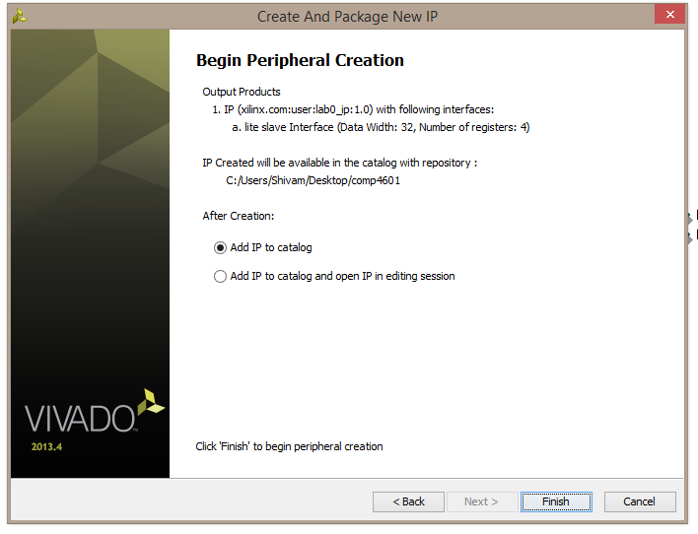

Figure 3‑5: Step 3.9, Finishing off the creation of Custom IP

You have now generated your own Custom IP component! In the next section, we will create a Vivado project file for the Custom IP so that we can independently modify the Custom IP and make it abstract from the high-level.

## Creating a Project file for the Custom IP

1. In the block diagram view (with **only** the ZynQ7 IP instantiated), select “**Add IP**” and find the lab0_ip that you just created.
2. Select the “**Run connection automation**” to the s00_AXI of the Custom IP that we just created. The end result should resemble that shown in *Figure* 3*‑*6.

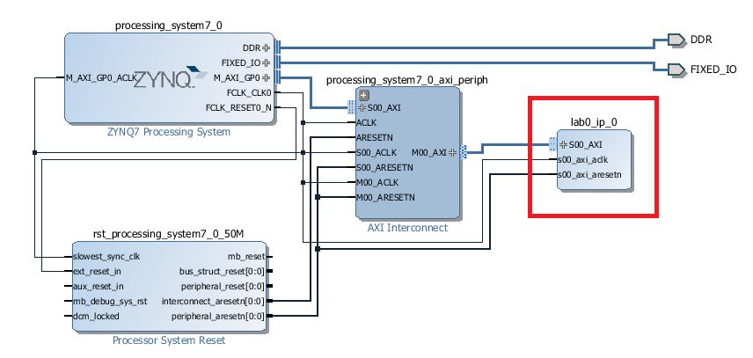

Figure 3‑6: Step 3.11, Adding Custom IP to your high level design

* 1. **Save** the block design and project file.
  2. Right click the lab0_ip_v1_0 (Custom IP) in your design and select “**Edit in IP Packager**”

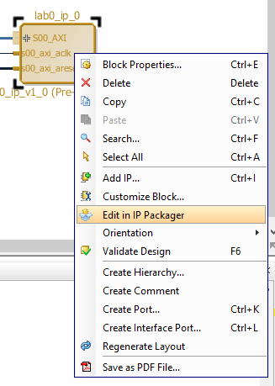

Figure 3‑7: Step 3.13, opening the IP packager

* 1. Select “**Ok**” in the project location screen

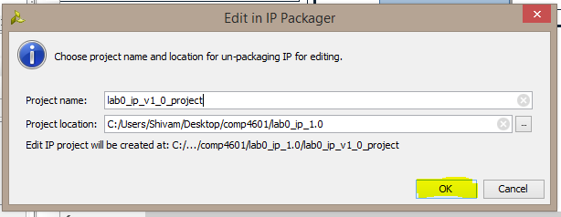

Figure 3‑8: Step 3.14, selecting the project name and location

* 1. When the new instance of Vivado shows up, the **first thing to do is close it** so that a permanent project file will form. This will make it easier to edit the IP in future, without the need to generate (and regenerate) temporary project files. It will also protect against data loss if Vivado crashes.  
     You should now have two project files as shown in Figure 3‑9 above. One is the high-level module (lab0) and the second contains the IP (lab0_ip_1.0).

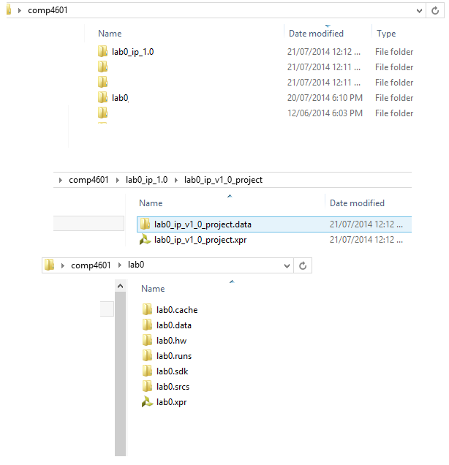

Figure 3‑9: Step 3.15, Expected directory structure

* 1. Now we will reopen the Vivado project file for the Custom IP. Navigate to the **lab0_ip_1.0/ lab0_ip_v1_0_project** folder and **open the** **.xpr** file shown above.
  2. Open the VHDL file named “lab0_ip_v_1_0_S00_AXI.vhd”, from the project manager view.

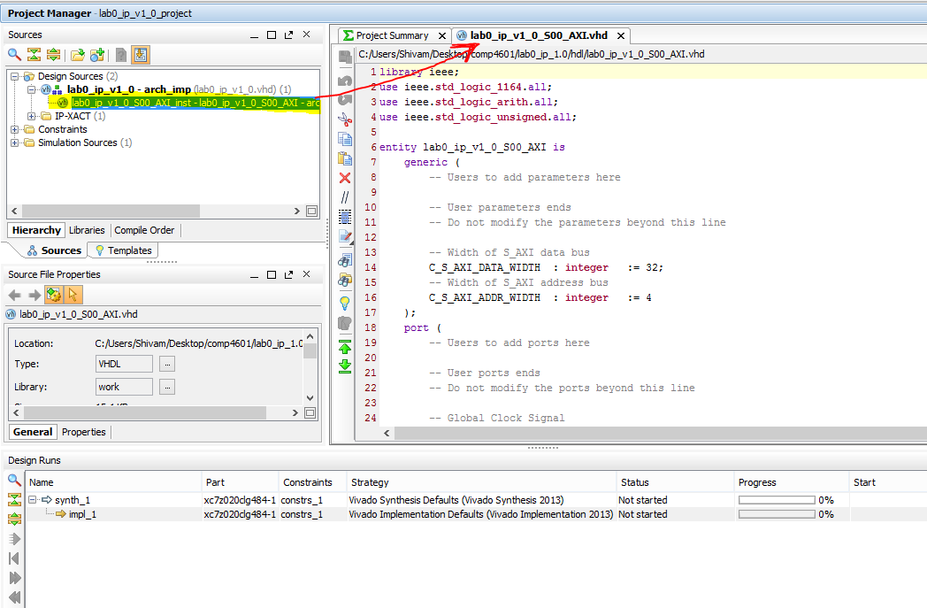

Figure 3‑10: Step 0, Opening the Slave AXI file

Now that we have a suitable development environment now in place, we can begin to develop our AXI peripheral. In the next sections of this manual, we will extend the operation of our new IP and repackage it so that we can upgrade the instantiated component in the high-level module.

# Customising the Custom IP

This sections provides an AXI-LITE interface tutorial and will walk you through the Slave AXI file that was generated in Section 3. You will be modifying the Custom IP component to set the stage for extending the generated skeleton implementation.

## AXI Tutorial

The Advanced eXtensible Interface (AXI) bus protocol was developed by ARM to control access to a shared bus. Some of the key features of this protocol are as follows:

* Independent address, control and data lines
* Incredibly simple handshaking due to the independent control lines
* Burst mode transfer support with the provision of only a starting address
* Uses a Master Slave model, with the Master being solely responsible for the arbitration of the bus; directing writes and requesting reads from the Slave

This section is limited to an overview of the AXI protocol. For more information, see the “AXI Reference Guide” [2].

The Master accesses a connected Slave by first applying an appropriate address on the address bus. Each Slave then determines if the provided address lies within its assigned addressable range before either ignoring or acting on the request. When connection automation was run on your Custom AXI IP, Vivado inserted a Xilinx AXI Interconnect between the Master and your Slave IP (See the “Xilinx AXI Interconnect documentation” [3]). The Interconnect provides a layer of abstraction that prevents a Slave from receiving any signal, unless the significant bits of the address match the assigned address range of the Slave. This is achieved by multiplexers and internally embedded routing data and explains why the observable address width of your Slave IP may not match the width of the bus. The downside of this abstraction layer is the introduction of some delay (which will be seen in the timing diagrams in the following subsections).

### AXI Writes

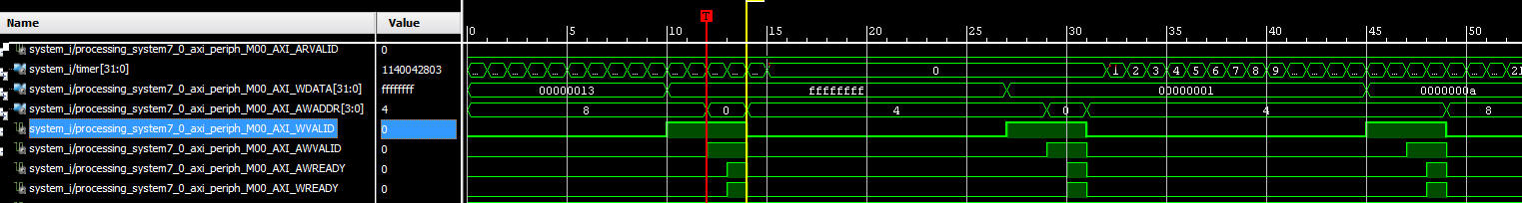

1

2

4

3

Figure 4‑1: Debug output for AXI write transactions

The waveforms in Figure 4‑1 show the Master writing 0xFFFFFFFF @ BASE_ADDR (0x0) then 0x00000001 @ BASE_ADDR (0x0), and finally 0x0000000a @ BASE_ADDR+4 (0x4). Note that the signals are prefixed with “M00_AXI” (Master AXI) instead of “S00_AXI” (Slave AXI). This is because the net was assigned a label by arbitrarily choosing the name of just one of the ports that it connects (in this case, the Master AXI port).

The AXI writes are initiated by the Master as follows, where the numbers refer to the labelled signals between clock cycles 10-12:

1. The Master* sets up **WDATA** (with 0xFFFFFFFF) and asserts **WVALID** (write data is valid)
2. The Master* sets up **AWADDR** (with 0x0) and asserts **AWVALID** (address valid)

*Master – strictly speaking it is the AXI interconnect which acts as the Master for this Slave AXI component, not the PS.

The Slave then responds as follows, where the numbers refer to the labelled signals between clock cycles 13-15:

1. The Slave asserts **AWREADY** (write address can be accepted by the Slave, determined by **WVALID && AWVALID**)
2. The Slave asserts **WREADY** (write data can be accepted by the Slave, determined by **WVALID && AWVALID**), at this point, **AWADDR** is also latched to free the bus for another operation.

Once **WVALID & AWVALID & AWREADY & WREADY** are all asserted

* + Slave register write is enabled
  + On the next clock cycle, the 14th clock cycle in the figure marked with a yellow line, **WDATA** is written to the appropriate Slave register in your custom IP.

### AXI Reads

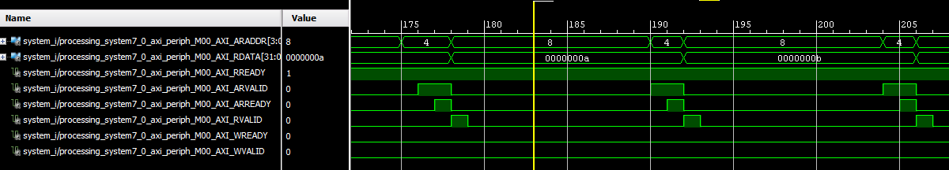

1

4

2

3

Figure 4‑2: Debug output for AXI read transactions

The waveforms in Figure 4‑2 show the processor reads, via AXI-LITE, from a FIFO at address BASEADDR+4 (0x4). The FIFO contains the data {0x0a, 0x0b, 0x0c, …..}.

The Master initiates an AXI read as follows, where numbers refer to the labelled signals between the clock cycles 175 – 177:

1. For AXI-LITE, the Master generally always has the signal **RREADY** asserted, signalling that it is able to receive data from the Slave
2. The Master then places the requested address (0x4) onto the **ARADDR** bus and asserts **ARVALID**

The Slave then performs the following, where numbers refer to the labelled signals between the clock cycles 177 – 180:

1. The Slave asserts **ARREADY** to signal that the address has been accepted by the Slave
2. The Slave then sets **RDATA** to reflect the appropriate data (0x0000000a), and asserts **RVALID** and de-asserts **ARREADY**. At this point (the 178th clock cycle) the correct data has been placed onto the bus and the Master has just one clock cycle to read it before **RVALID** is de-asserted.

Since the Master (AXI Interconnect) and the Slave are clocked at the same rate (FCLK_CLK0) the **RVALID** signal can be viewed as a latch signal for the AXI Interconnect to store this data into its own internal register and later forward it to the up-stream Master, the Zynq Processor.

## Customising the Custom IP

Based on the tutorial on the AXI protocol in the previous subsection, it should be clear that AXI signals can be used by the hardware designer to determine whether or not a read or write has been requested by the Master. It should be noted that the response to the request is entirely up to the Slave and may include side effects. For example, a write to a specific Slave address may push data onto the tail of a FIFO, while a read operation from the same address might pop data from the head of this FIFO. Alternatively, a register may be aliased by an alternate address which could be configured to respond with a logical NOT of the underlying data.

There are a few files and naming conventions to take note of before we begin to modify the IP:

* **Slave_AXI** (lab0_ip_v1_0_S00_AXI.vhd) – a generated file which implements the AXI-LITE handshaking process and stores all writes to local registers. These same registers are currently configured to also be used for read response values.
* **Toplevel** (lab0_ip_v1_0.vhd) - refers to the VHDL file that encapsulates the Slave_AXI file described above. You’ll notice that it is largely empty. This is where we will be focussing our implementation efforts. When coding your own designs, it is recommended that you use this file only as a connection point between your VHDL components. Given that this is a relatively short lab, we will code entirely within this file for convenience.

*Figure* 4*‑*3 below shows the overall organization of our design. The high-level project encapsulates the Zynq, the AXI Interconnect and your Custom IP block. The source for your custom IP block resides in an independent project and contains the files mentioned above. The green arrows in *Figure* 4*‑*3 denote the changes we will be making to expose some of the internal signals of the Slave_AXI file into the Toplevel where we can then design the peripheral directly, or instantiate other components. The reason for this is so that we preserve the protocol implemented by the Slave AXI file and concentrate our efforts on the implementation of the device logic (shown in orange).



Figure 4‑3: System diagram denoting the changes we are about to make (green arrows) and a high level overview of how all the components are connected.

### Changes to Slave_AXI

Figure 4‑4 presents a subset of the Slave_AXI design file. You should notice that the **RDATA** bus for AXI reads is driven by ***reg_data_out***. The generated Slave implementation drives this signal from the local signals named ***slv_reg***. The first modification will be to introduce four externally visible signals to take the place of these signals during a read operation. We will call these signals ***datain*** as shown in Figure 4‑4.

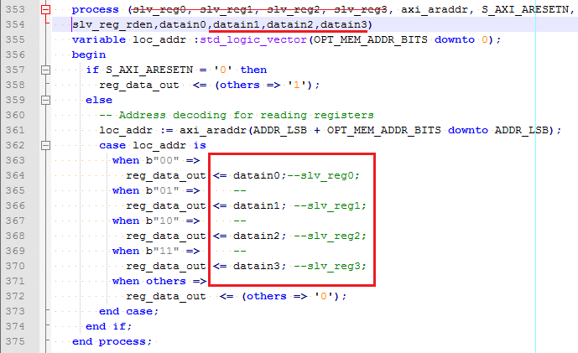

Figure 4‑4: Changes to AXI read data within lab0_ip_v1_0_S00_AXI.vhd

Now that we have taken care of the output values, we next need to expose the data that the master writes to this Slave so that their values can be used by the Toplevel. In this case, instead of modifying the Slave logic, we simply map the local signals named ***slv_reg*** to external signals named ***dataout***. Recall from the timing figures in Sections 4.a.i and 4.a.ii, that the address bus value is only valid for a very short amount of time. The ***axi_awaddr*** and ***axi_araddr*** registers are used in the generated code as latches to ensure that their values are persistent for the duration of a transaction. These signals will also need to be made available to the Toplevel. The changes that need to be made are shown in Figure 4‑5.

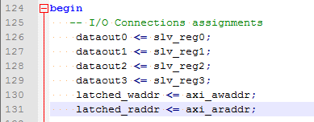

Figure 4‑5: Exposing the written values and latched addresses within lab0_ip_v1_0_S00_AXI.vhd

To ensure that the Toplevel can access the signals introduced above, the port definition of the Slave_AXI component need to be modified as shown in Figure 4‑6.

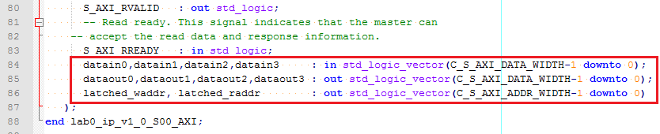

Figure 4‑6: Required signal additions to the Slave_AXI entity declaration

### Changes to Toplevel

There are two ways that one can utilise the values from the processor:

* The first approach is to use registers which will be accessed independently by both the AXI bus and the underlying peripheral. The peripheral need not know exactly when a read or write operation has taken place.
* The second approach is to handle AXI communication in real time. One can effectively ‘snoop’ the AXI bus lines and be reactive to communication from the master as it occurs. An example would be an address which always reads 0, but when written with any value, a state transition occurs within the peripheral. The data in either case, has no tangible value.

We’ll come back to these ideas in the Section 6, but for now we’ll stick to some simple modifications so that we can determine if the changes that we have made to the IP source have carried through to our high-level design.

Your next task is to modify the Toplevel source file to reflect the port changes that were made to the Slave_AXI component in Section 4.b.i as shown in Figure 4‑7. You will also need to declare these signals within the Toplevel.

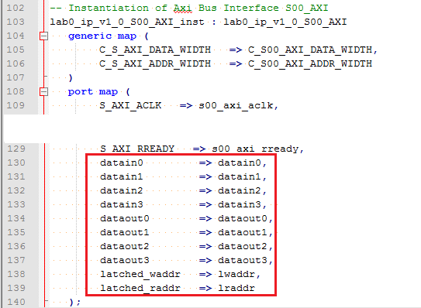

Figure 4‑7: Signal additions to the port map of the Slave_AXI. Lines 110-128 require no changes.

We will now implement some trivial logic (shown in Figure 4‑8) for the purposes of testing the changes that we have made. Notice that the registers which store the data written by the Master (***dataout0***, ***dataout1***) are routed to the AXI read registers (***datain1***, ***datain0***). It is writes to register 1 (BASE_ADDR + 0x4) which set the read value of register 0 (BASE_ADDR + 0x0). Similarly, writes to register 0 will set the read value of register 1. Meanwhile, for the reads from register 2 (BASE_ADDR + 0x8) and register 3 (BASE_ADDR + 0xC), the constant values of 3 and 4 will be read respectively and writes to these registers will be ignored.

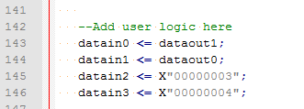

Figure 4‑8: Simple IP logic to test the changes that we have made

Within the IP project file, check for compilation errors by clicking on the “**Synthesise**” button in the left hand pane. Once you have corrected any outstanding errors, all that remains is to save these changes within the IP. In the next section of this manual, you will update the instantiated component within your high-level design and test the implementation of your updated IP via the PS.

The importance of the steps outlined in this section is that you no longer have to worry about the Slave_AXI implementation file because you have exposed all of the signals that will be useful for your implementation. From now on, you are free to modify only the Toplevel file when changing the behaviour of your custom IP or to instantiate additional components.

# Packaging and testing your IP

In this Section we will package the Custom IP (Toplevel and Slave_AXI files) that we have generated and modified. Once packaged, it can be instantiated in the high-level design as an independent IP block in the same way that we instantiate any other IP block. Then, all that remains is to write some C (driver-like) code to interact with the IP and ensure that the changes that we have made are correct. This process will need to be repeated every time you change the implementation of the IP, however, a lot of the steps below are **conditional**.

## IP Packager (Within the Custom IP’s Vivado project)

1. Select the “**Package IP”** in the project manager section in the left hand pane.

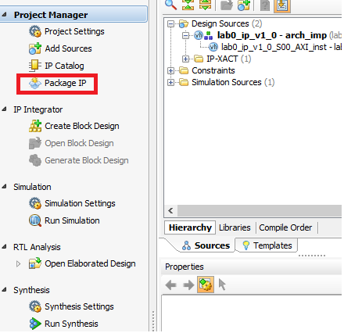

Figure 5‑1: Step 5.1, starting the packaging process

1. At the start screen, leave all the options the same except for the version number; ensure that you **INCREASE** the version number (e.g. 1.0 -> 2.0). The reason for this is so that Vivado will detect the version change and prompt you for an upgrade. You should also alter the display name to reflect the version number change.

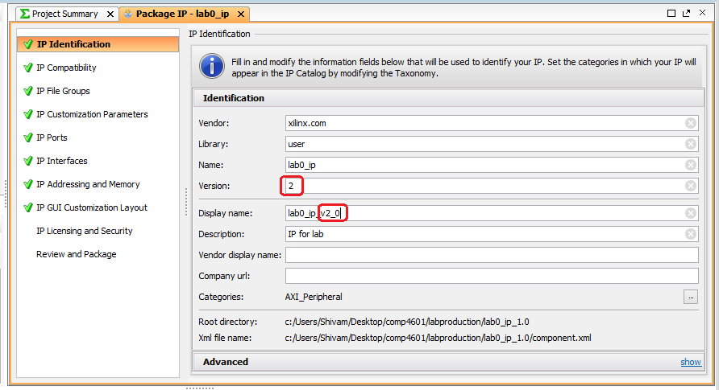

Figure 5‑2: Step 5.2, altering the version number for your IP

1. **If** the changes to the file involved adding new VHDL files, they must be added in the **“IP File Groups”** to both the “VHDL synthesis” and “VHDL Simulation” folders, as shown in Figure 5‑3.

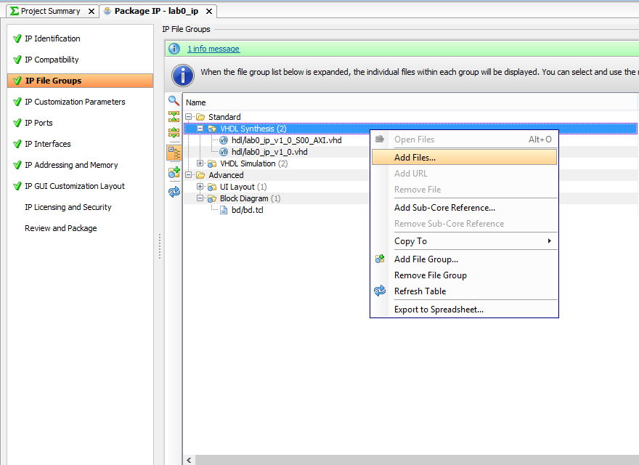

Figure 5‑3: Step 5.3, Add VHDL files to the IP definition if needed

1. **If** the ports to the Toplevel have been changed, then use the “**IP Ports**” page by clicking on the Port import dialog and following the prompts.

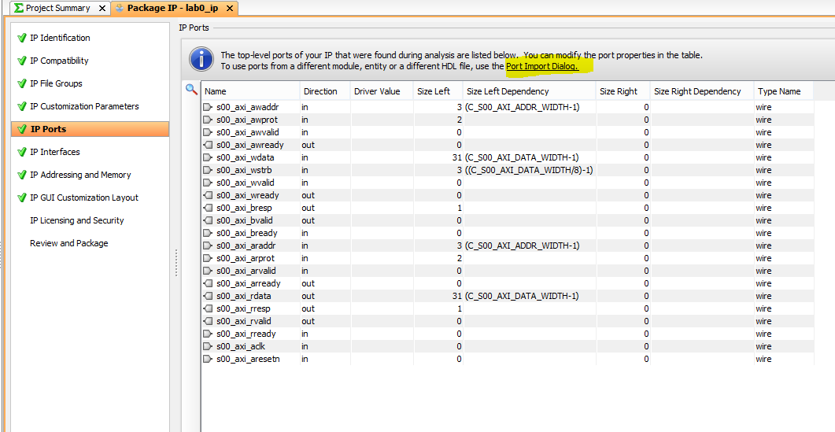

Figure 5‑4: Step 5.4, Modifying IP ports if needed

1. **If** you used the “**IP ports**” page to add/remove ports, you should now go to the “**IP GUI Customization Layout**” and use the IP GUI customization layout wizard to regenerate the image of the IP component. Simply follow the “run the wizard” link to regenerate the diagram of the IP.

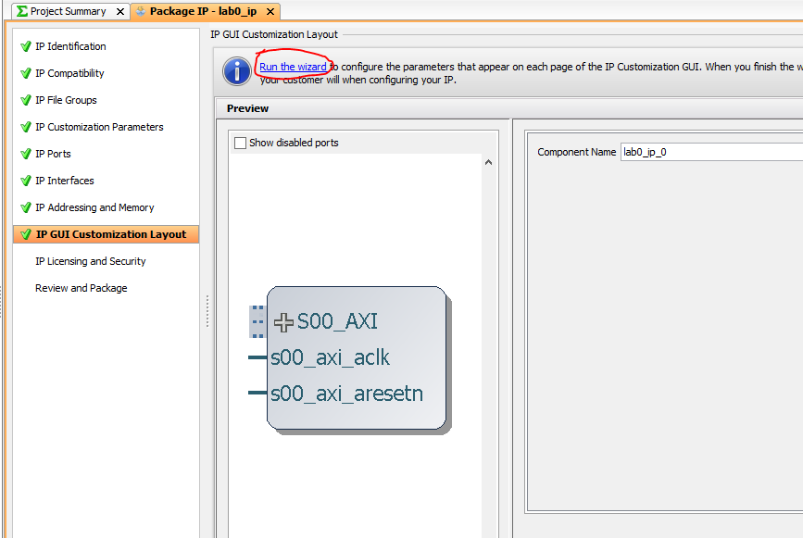

Figure 5‑5: Step 5.5, Regenerating the IP GUI

1. Complete the process by clicking the **Re-Package IP** button in the “**Review and package”** screen.

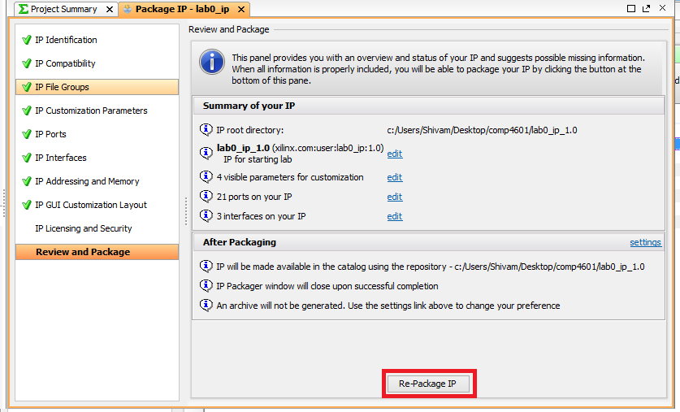

Figure 5‑6: Step 5.6, finalising the packaging process

Screens which were skipped:

* **IP compatibility** - is used to list the valid target boards for the IP. It should always include the ZYNQ board for our designs.
* **IP Customisation Parameters** – should be used if the customisation parameters (generic parameters) for the IP have been changed.
* **IP interfaces** – This screen is used to match or create a standardised interface port by grouping signals (e.g. a FIFO_WRITE port for interfacing with a Xilinx FIFO instance).
* **IP Addressing and Memory** – Informational only
* **IP Licencing and Security** – Informational only

## IP upgrade in high-level design (Within the high-level Vivado project)

1. **Reopen the high-level design Vivado file** and open the Block Design
2. Select the **TCL console** window and run the following commands
   1. ‘update_ip_catalog –rebuild’ This refreshes the IP repositories specified in Project Settings > IP > IP Repositories (you can do this manually if you wish)
   2. ‘report_ip_status -name ip_status_1’ This generates an IP report which shows whether or not the IP in your design are up to date. You should see that lab0_ip_0 has a “Major Version Change” as shown in *Figure* 5*‑*7.

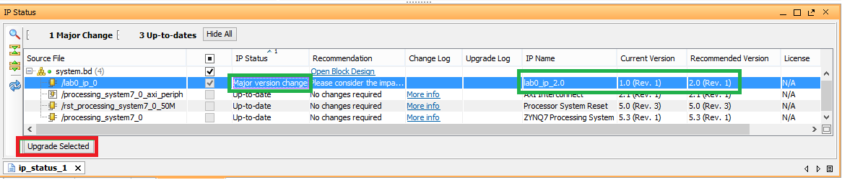

Figure 5‑7: Step 5.9, Vivado reporting changes to the IP in your high-level design

1. Tick the checkbox associated with our IP and click the **upgrade selected** button. Vivado will now upgrade the instantiated IP while retaining all existing connections.
2. Regenerate the HDL wrapper for your high-level design and generate a bitstream.
3. Open Implemented Design and export it to the SDK so that we can begin the development of driver software for interfacing with our custom IP.

## Interfacing with the Custom IP

In this section you will write C code to integrate and test our new IP with the CPU. When creating the **application project**, it is best to use the “Hello World” example project as a template because one of the first steps that the application performs is to initialize the UART.

You will need to **#include “xparameters.h”** to import the definitions shown in Figure 5‑8. These addresses should correspond to those listed in Vivado’s “**Address Editor**”. Since the generated IP has a 4 register implementation, only the bottom 4 bits of the address will be seen at the Slave (byte addressing, 32 bit data bus). You should also **#include <xil_io.h>** to get the Xil_Out32/Xil_in32 function definitions.

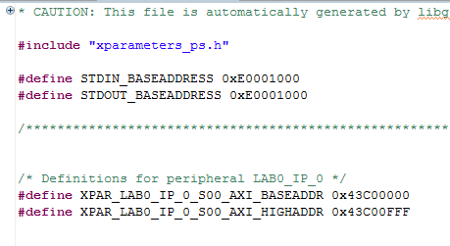

Figure 5‑8: AXI address range of the AXI peripheral, inside “xparameters.h”

Once you’ve verified this, go back to “**helloworld.c**” and add the code shown in Figure 5‑9 below. This code writes 4 values and reads 4 values back from the IP. The expected output should be “Values read = 00000002, 00000001, 00000003, 00000004” if you followed the steps in Section 4.b of this lab correctly.

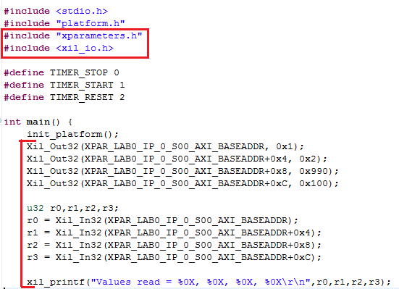

Figure 5‑9: C code which is used to test our Custom IP

If you were to write to the address: XPAR_LAB0_IP_0_S00_AXI_BASEADDR + 0x10, it would mimic the effect of writing to XPAR_LAB0_IP_0_S00_AXI_BASEADDR + 0x0, since the Slave only sees the least significant 4 bits of the address.

The xil_io.h file contains definitions for IO functions of various widths such as Xil_in8, Xil_out16. You may have considered using these functions given that we are reading and writing such small data sizes. A problem with this approach lies in our AXI bus abstraction layer where we have chosen not to expose the signals required for detecting these access widths. It is common to find that AXI devices will only support 32 bit IO.

You will also find definitions for fixed size data types, such as u32 (unsigned 32 bit), within xil_io.h. As you may already be aware, the size of an *int* data type is not well defined. For this reason, it is good practice to use fixed size data types when accessing fixed size peripheral registers.

# Implementation Exercises

By now, you should be familiar with the process of modifying a Custom IP component, repackaging the IP and integrating it back into your high-level design. In this section, we will extend the custom IP design to produce a useful AXI peripheral. The peripheral will be split into 4 functions; a timer, a FIFO, a GPIO controller and CPU accessible BRAM. All exercises are intended to be implemented in the Toplevel file of the Custom IP. The AXI register layout for this lab is shown in Figure 6‑1.



Figure 6‑1: AXI Protocol for the Implementations to follow

## Timer implementation

The first task will be to implement a simple AXI accessible, 32 bit timer within the FPGA. The timer will run at FCLK_CLK0 and counts the number of clock cycles elapsed since the timer was last reset by the user (CPU; AXI Master). The register interface for the timer is shown in Table 6‑1:

Table 6‑1: Timer register interface

|  |  |  |  |  |  |  |  |
| --- | --- | --- | --- | --- | --- | --- | --- |
| Bit | 31 | 30 | ….. | …… | …… | 1 | 0 |
| Function on write | n/a | n/a | ….. | …… | …… | Reset | Enable |
| Function on read | Timer value | | | | | | |

The timer can be considered to be a counter which has a reset signal controlled by bit 1 of ***dataout0*** and an enable counter signal controlled by bit 0 of ***dataout0***. In this case, the counter is counting positive transitions in the FCLK_CLK0 signal. The implementation of the timer will be quite simple since AXI writes from the Master to the Slave are stored in the Slave registers which we have piped out to the Toplevel.

After implementing the timer control logic, all that remains is to get the value of the timer back to the Master (PS). Since the selected AXI data bus width was **32 bits,** we will implement a 32 bit timer. The timer value will need to be provided every time the user reads from 0xYY0 (where YY is any number). To achieve this, we simply need to set the ***datain0*** signal to be the current value of the timer.

The final step for this exercise is to export the design to the SDK and modify the IP test code to exercise the timer and ensure that it operates correctly. An example solution can be found in Appendix A in case you wish to verify your IP implementation.

## FIFO implementation



A FIFO is a common design element that is used to queue a transmitted data stream until the receiver is ready to collect it. The FIFO is particularly important when transferring data between two clock domains (subsystems that are clocked at different rates). *Figure* 6‑2implementing. It state transitions must not occur *during* an AXI transaction. This is particularly important for a read operation where the data read will be unpredictable if the data on the data bus does not remain stable



Figure 6‑2: FIFO Finite State Machine (FSM)

Implementing a FIFO will be more challenging than the timer since we now need to consider peripheral state and state transitions. State transitions are triggered by AXI communication as follows:

* **Write –** When a write is taking place, we should read the data bus (**WDATA**)and set this as the FIFO data input. We should also enable a FIFO write signal for exactly one clock cycle such that the FIFO knows to push the current data to its tail. Referring back to Section 4.a.i and the original source code for Slave_AXI, it should be noted that the **S_AXI_WREADY** is asserted by the Slave for exactly one clock cycle once the write was successful. We can probe this signal as high and once so, enable a write to the FIFO. For example, we will be performing our FIFO insertion operation at the start of the 14th clock cycle in Figure 4‑1 on page 11.
* **Read –** From the timing diagrams in Section 0 on page 11 and 12, it should be apparent that the Slave has only a couple of clock cycles to correctly set the data to be read onto the data bus. Instead of trying to provide a read result at the exact instance it is required, we shall set up the **next read** value as soon as any read transaction has completed. Referring back to Section 124.a.ii on page 12 and the original source code, it should be noted that when **S_AXI_RVALID** is asserted, the Slave has updated the data bus with valid read data. Furthermore, this signal is asserted for exactly 1 clock cycle. If we were to wait for this signal to be asserted on the rising edge of a clock pulse, we know that the data, ***datain1***, has been accepted by the Master and we can safely replace the value of ***datain1*** to be the next value in the FIFO. The position in time at which this happens is denoted by the start of the 179th clock cycle in Figure 4‑2 on page 12.

The last point to note is that you also have to check the address of the write/read operation to ensure that it is a FIFO operation (denoted by the addressing corresponding to 0xYY4). However if you refer back to the timing diagrams in Figure 4‑1 and Figure 4‑2, you’ll notice that the read/write address is only valid for a very small amount of time. Therefore, we will need to make use of the **latched write and read addresses** and check that the [3..2] bits are equal to “01”.

Figure 6‑3: Run through of FIFO behaviour



1. Initial FIFO, after 3 values have been written

2. After 3 values read by user, note that the next read should not move read ptr. Set bit 31 to indicate that the current read is invalid

3. After 4 more values have been written by the user, note read ptr is now valid

4. More values written, note the write ptr has moved beyond read ptr. Undefined behaviour.



|  |  |
| --- | --- |
|  |  |



The FIFO diagrams in Figure 6‑3 denote the functioning of the FIFO; they should all be fairly easy to follow. The one which causes some concern is the 4th diagram where the user has written over data that has not yet been read by the user. It is up to you to decide on how to respond to this case:

1. Just ignore the transaction and assume the user knows not to overfill the FIFO
2. Store the current size of the FIFO by counting writes and decrement with reads. If the FIFO is full, the request should be ignored. Note that it will not be possible to provide the client with **immediate** feedback when this occurs as this information is only reported by a read transaction.

. The specification for the FIFO that you will design is as follows:

* FIFO data width of **16 bits** and a capacity of **1024 words.** This should be implemented as block ram in the Toplevel. The BRAM should have both an address and a data width of 16. If you need a refresher on the use of BRAM refer to the “Distributed and Block ram on Xilinx FPGA’s” guide [5]
* If we reach the end of FIFO addressing, reads and writes should wrap around the BRAM. This can trivially be achieved by ignoring underflows and overflows in FIFO position.
* Reading from an empty FIFO should not affect the FIFO position. If the user tries to read from an empty FIFO, bit 31 (Most Significant Bit) should be set to indicate that the data is invalid. It is expected that the user checks this bit for data validity.

Table 6‑2: FIFO register interface

|  |  |  |  |  |  |  |  |
| --- | --- | --- | --- | --- | --- | --- | --- |
| Bit | 31 | 30 | ….. | 15 | …… | 1 | 0 |
| Function on read | Read Invalid | n/a | ….. | Data out | | | |
| Function on write | n/a | n/a | ….. | Data in | | | |

,verify your design by writing C code on the PS to sequential 24

## GPIO implementation

The GPIO implementation will mimic that of the Xilinx GPIO IP as seen in the Advanced Embedded design (AED) Lab 1, however, it will be implemented entirely within our Custom IP component. This exercise will involve adding ports to our IP as well as external pins and constraints to our high-level design in order to extend the connectivity of our IP beyond the AXI bus.

We will implement two registers:

* LED – The value of this register can be assigned directly from the most recent AXI write transaction (***dataout2***). The output of this register should be directly connected to the LED pins.
* Switch – The value of this register is associated with the logical state of the SWITCH pins and should be reported on the data bus during AXI read transactions from ***datain2***.

Once you have implemented this very simple hardware solution, you will need to repackage the IP. Since you have added two ports to the IP, you’ll need to run the “**IP ports**” and “**GUI customisation**” of the IP packager as described in Section 5.a on page 17.

Finally, within the high-level design, you need to declare the LED’s and SW’s and connect them to external pins (see AED lab1 for pin assignments within the xdc file and refer to the “Zedboard user manual” [4] for the IO pin numbers). Figure 6‑4 shows what your high-level design should resemble. For testing your IP through the PS, it is recommended that you write an infinite loop which reads the switch values and writes this pattern back out to the LED register.

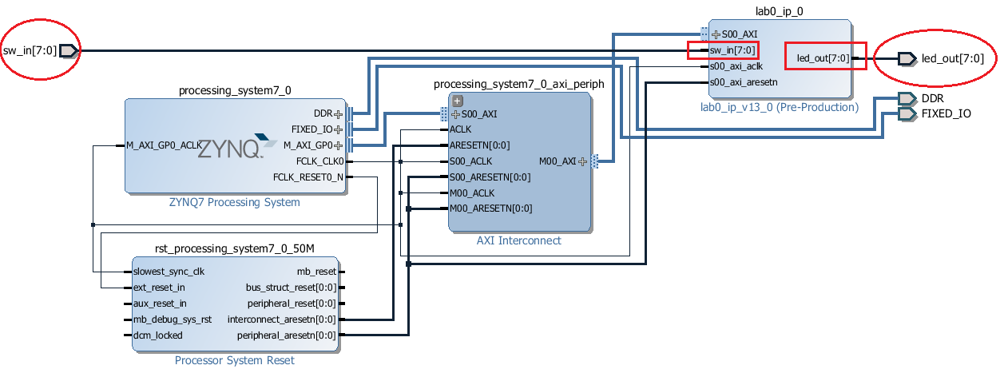

Figure 6‑4: High-Level Vivado project file, denoting the relevant pin to port connections to be made

## Block RAM implementation

Block RAM plays an important role in peripheral local storage for PL IP components. As an example, you may wish to perform a DSP operation on an image. This image may need to be uploaded from the CPU into the IP for efficient random data access. The image may also need to be downloaded again later such that the processed result can be forwarded to the next process block.

For this exercise, it is assumed that you are now familiar with the design flow. We provide you with only the register API and leave the implementation details entirely to you.

API Assumptions:

* 16 bit BRAM data width.
* 16 bit BRAM address width.
* The Master can read and write to any address within the BRAM.

Table 6‑3: Block RAM register interface

|  |  |  |  |  |  |  |
| --- | --- | --- | --- | --- | --- | --- |
| Bit | 31 | 30 | ….. | 15 | …… | 0 |
| Function on read | n/a | n/a | ….. | Data at active address | | | |
| Function on write | A/D  select | n/a | ….. | If bit 31 = 0: Active address select  If bit 31 = 1: Data to write to active address | | | |

Bit 31 selects the context for an AXI write transaction. If this bit is not set, the data should be interpreted as a BRAM address selection. When this bit is set, the AXI data represents the 16bit value which should be written to the current active BRAM address. During a read request, bit 31 is always ignored and data should always be read from the active BRAM address. For example, to perform a read or write transaction at a particular address, you would need to write a driver which executes the functions shown in *Figure* 6*‑*5.

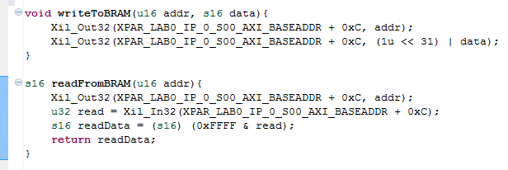

Figure 6‑5: C functions to interface with the BRAM within the Custom IP

# Conclusion

Now that you are comfortable with utilising Vivado’s built-in tools to generate and modify Custom IP, and the design flow related to the process; it’s time to go out and design full-fledged hardware solutions. While designing your own solutions we have a few recommendations:

* **Simulation –** In terms of compilation time and quality of debugging output, Simulation provides the fastest way to test your design. You should first make sure that your individual components are flawless before attempting to integrate them with the AXI bus. This will save a substantial amount of time when diagnosing faults. One important point to keep mind while simulating on an FPGA with clock speeds in the MegaHertz range is that the amount of clock cycles which occur within a second are more than what you could possibly view within a simulation frame. Consequently ensure that your FSMs within the custom IP are initiated by an AXI transaction, and STOP when the transaction has completed. Your FSMs should not be waiting for a second AXI transaction before completing an operation. This is particularly evident if you decide to print characters to the console between reading and writing data from the Custom IP. A large amount of clock cycles will be used up writing out to the UART, thus distorting perception of time between the two AXI transactions.
* **Debug –** If your hardware is not working the way you envisioned (despite simulations telling you otherwise) one method of identifying the problem is to set all relevant signals as outputs to the Toplevel of the Custom IP. Then, utilising the knowledge gained in lab2 of Advanced Embedded Design, set all of these ports as debug. Once you have assigned the debug cores, set the waveform to trigger on a change in one of the AXI signals and run through your software, and finally analyse the waveform to work out where the issue lies. This approach has been tried and found to be much faster at identifying problems than trying to simulate your Toplevel/Custom IP individually since that approach involves having to “simulate” Master AXI behaviour!

References

[1] Xilinx Custom IP guide, slightly outdated but quite comprehensive guide to Custom IP

<http://www.xilinx.com/support/documentation/application_notes/xapp1168-axi-ip-integrator.pdf>

[2] AXI reference guide

<http://www.xilinx.com/support/documentation/ip_documentation/ug761_axi_reference_guide.pdf>

[3] Xillinx AXI Interconnect

<http://www.xilinx.com/support/documentation/ip_documentation/axi_interconnect/v2_1/pg059-axi-interconnect.pdf>

[4] Zedboard user manual

<http://www.zedboard.org/sites/default/files/ZedBoard_HW_UG_v1_1.pdf>

[5] Block and distributed RAM’s on Xilinx

<http://vhdlguru.blogspot.com.au/2011/01/block-and-distributed-rams-on-xilinx.html>

Appendix

Appendix A (Timer Solution)

--Timer implementation: uses the dataout0 signal to represent

--the current value which has been written to the timer’s control

--register. And datain0 signal to output the timer value.

**process(**clk**,**dataout0**)**

**begin**

**if** **(**dataout0**(**1**)** **=** '1'**)** **then**

--"asynchronous" reset

timer32 **<=** **(others=>**'0'**);**

**else**

**if** **(rising_edge(**clk**))** **then**

**if** **(**dataout0**(**0**)** **=** '1'**)** **then**

timer32 **<=** timer32 **+** X"00000001"**;**

**end** **if;**

**end** **if;**

**end** **if;**

**end** **process;**

datain0 **<=** timer32**;**